Rahotu School

Information Booklet 2017



*Whakatika Kia Pai -* Set out to do your best

“Keeping the flames of learning alive”

Our mission is to provide…

A caring and challenging environment.

A friendly and welcoming place for students, parents, teachers and visitors.

An emphasis on quality learning and teaching.

An environment that enables students to reach their full potential.

A progressive school which is seen as the “hub” of the community.

Rahotu School

5825 Surf Highway 45

Rahotu

4639

Phone: 7638 658

Fax: 7638 472

Cell Phone: 0279332308

Email [admin@rahotu.school.nz](mailto:admin@rahotu.school.nz)

[principal@rahotu.school.nz](mailto:principal@rahotu.school.nz)

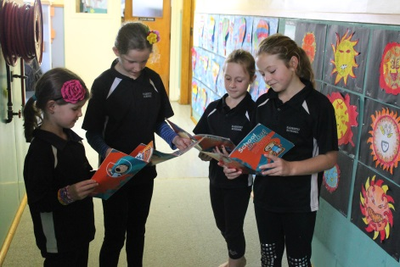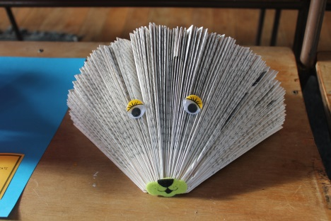

Greetings/Nga mihi nui ki a koe

Welcome to the 2017 school year. This handbook has been prepared to broadly outline the school’s operations. Please read it carefully and if you have any queries do not hesitate to contact me.

2017, is again a focus year on LEARNING! –We are creating a learning system which builds the assessment capability of students, teachers, BOT and parents where everyone is involved in inquiring into the effectiveness of their practice and seeking ongoing improvement so there is success for all.

Ko te tamaite te puptatake o te Kaupapa- “THE CHILD” -the heart of the matter.

All students will be actively involved in helping their teachers ascertain what they have learned, what their strengths are and where their gaps may be.

Our FLAME respect programme, our Health Promoting Schools programme and key competencies all contribute to safety for all and a positive environment so the scene is set for learning to be accelerated.

We want all children to be proud of their culture, have pride in their unique identity and language. We want our families/Whanau engaged and supporting their children’s learning and making sure they are ready for learning each day.

|  |  |
| --- | --- |
| Term Dates for 2017: | |
| Term 1 - Monday 1 February – Thursday 13 April  Term 2 Monday 1 May – Friday 7 July  Term 3 - Monday 24 July– Friday 29 September  Term 4 - Monday 16 October –Friday 15 December | |
| Terms | Significant Events – Dates to be confirmed: |
| Term One | Meet and Greet the Teachers, Whole School Picnic, |
| Term Two | School wide Production, Interschool sport |
| Term Three | Interschool Sport |

|  |  |
| --- | --- |
| Term Four | Calf and Lamb Day, Reports |

**Strategic Goals – Charter 2017**

*After consultation with the school community, parents, students and staff, the Board of Trustees have set the following Strategic Objectives as its Strategic Plan that will underpin the School’s Annual Plans for 2017.*

|  |  |  |
| --- | --- | --- |
| STUDENT  LEARNING | To continue to develop a culture of learning in the school where everyone; students, teachers, Principal, Parents/Whanau and BOT) are involved in inquiring into the effectiveness of practice and seeking ongoing improvement so an increased number of students are achieving At or Above National Standards. | Literacy and Numeracy Targets in relation to achievement data  *Writing  *Mathematics |
| STUDENT ENGAGEMENT | Student engagement improved by regular attendance, being at school on time and being enthused about improving their level of attainment. This will be enhanced by innovative staff who are supported by strong professional development experiences and a focused appraisal system. | Working alongside the Ministry of Education on professional development to improve Teacher knowledge In teaching Literacy for all staff.  Close monitoring of attendance and lateness. |
| COMMUNITY ENGAGEMENT | All students encouraged and supported to be involved in all school activities and their learning, in partnership with their parents and teachers. Including special education needs students, target students, students who are talented in any area of the curriculum and our Maori students. | Identify and promote high interests and special talents of our students in the arts.  Provide leadership opportunities for senior students. |
| HEALTH AND SAFETY | Shared common values/behaviour system for students, teachers and Whanau/families that are exhibited and evident in all that we do-FLAME programme. | Ensure the FLAME values are pivitol in school learning, behaviour and pastoral support. Focusing on a value per term. |
| SCHOOL FINANCE AND PROPERTY | Buildings grounds and resources that are attractive, well maintained and designed for the learning needs of the 21st Century students. | Maintenance painting in interior and exterior. Upgrade the external area of our school hall  Plan for school gardens-vegetable /fruit trees along the boundary fence line |

**Target for Student Improvement** -

*After considering all the data from 2016 we have identified the following areas of learning we wish to improve the level of achievement*.

1. Annual Target in Attendance:

To establish a working relationship between parents and the school to ensure our students are attending school for a minimum of 90% of the term.

1. Annual Target in Writing:

Increase the number of students working At or Above National Standards in written language. To fund a teacher, reduce class sizes and employ a teacher aide to support this target. Make links with other schools to ensure consistency across moderation methods.

1. Annual Target in Mathematics:

Increase the number of students working At or Above National standards in Mathematics.

To provide professional development opportunities in the teaching and delivery of Mathematical programmes across all levels.

1. Annual Target in Technology:

To upskill teachers in the delivery of IPDA Application to support current programme delivery in Literacy and Mathematic

**STAFFING**

|  |  |  |  |
| --- | --- | --- | --- |
| Teaching Staff | | | |
| Located | Position | Name | Position of Responsibility |
| Office | Principal | Mrs Brigitte Luke | Schoolwide |
| Office | Senior staff | Mrs Elaine Wilson | SENCO- Leader of Students – OORS Students  Reading Recover Teacher |
| Room 7 | Year 7/8 | Whaea Esther Ward-Campbell and Matua Chris (One day per week) | Leader of Physical Health  Leader of Math Curriculum |
| Room 6 | Year 6/7 | Mrs Christine Julian | Leader of FLAME |
| Room 5 | CRT/PRT | Mr Richard Carr | Leader of Technology |
| Room 4 | Year | Mrs Rochelle Purdie and Mrs Beccy Muggeridge | Shared teaching position |
| Room 3 | Year | Mrs Suzanne Davidson | Leader of Te Reo |
| Room 2 | Year | Miss Jacquie Jones | Junior Teacher |
| Room 1 | Year 1/2 | Miss Kylie Lancaster (nee Lashford) | Hauora Leader  Junior Teacher |
| Support Staff | | | |
| Office |  | Mrs Leanne Wiringi | School Secretary, BOT Secretary |
| Room 6-7 | Support Staff | Mr Colin Rata | Student support – playground  Classroom programmes |
| Room 4-5 | Support  staff | Miss Ninah Cran | Student support  Classroom programmes |
| Library | Support | Mrs Karen Hill | Libarian |
| Cleaner |  | Mrs Delisa Rutland | Schoolwide |
| Cleaner/Caretaker |  | Mr Leith Mikaere | Schoolwide |
| Groundsperson |  | Mr Murray Horo | Field |
| Additional Support Staff – External Agencies | | | |
| RT Maori | Hawera | Maora Koopa | Support Te Reo and Tikanga |
| RT Literacy | Hawera | Tina Johnson | Student support Literacy |
| RTLB | Opunake | Tash Kruger | Student support behaviour and learning |
| Health Nurse | Opunake | Stephanie Livingstone | Public Health Nurse |

**Board of Trustees**

The school is governed by the Board of Trustees. The Board is responsible for all aspects of the school. Each Board Member has specific responsibilities. Elections are held every three years by poll. Elections will be held this year. Board of Trustee Meetings are held at least twice a term, in the meeting room at Rahotu School. The date of each meeting is advertised in the school newsletter.

Officers:

|  |  |
| --- | --- |
| **Positions:**  Bryan Worthington  Jason Allan  Cory Helms  Neil Pennington  Angela Hapata  Richard Carr  Brigitte Luke  Leanne Wiringi | **Personnel:**  Chairperson  Personnel  Finance  Property  Health and Safety  Staff Representative  Principal  BOT Secretary |

**Home and School Association**

The Home and School Association is a committee of parents who meet in the School Staffroom. The date for each meeting is advertised in the School newsletter.

Any interested parents/caregivers may come to these meetings. Every parent is part of the Home and School and we encourage everyone to take an active role.

The role of the Home and School is: Fundraising and the liaison forum between staff and parents on any school event and /or curriculum issues.

|  |  |  |  |  |
| --- | --- | --- | --- | --- |
| **Positions:**  President  Treasurer  Secretary  Uniform Officer Jan Chard  Fundraising | | | **Personnel:**  Mel Thompson  Karen Helms  Shelly Bolland  Belinda Allan All All parents  All parents | |
| **School Daily Programme** –  *The school day is divided into four blocks. (There may be slight changes to timetable due to Teacher Aide availability – please see you child’s teacher)*  *From Monday-Thursday* | | | | | | |
| Get Ready Bell | | 8.40am | Programme | | Friday has slots for different learning activities and this can change each term. Activities can include- “Discovery Time” for Rooms 1, 2 and 3, sports, assembly, FLAME Friday, Maths Games, Art, School singing, Kapa haka, electives etc . Aquatics will change the Time table during the first half of Term 1. This is available from your child’s teacher. | |
| School Starts | | 8.45am |  | |
| Block ONE | | 8.45-10.00am | Mathematics | |
| Break 1 | | 10.00-10.15am |  | |
| Block TWO | | 10.15-11.25am | Reading | |
| Break 2 | | 11.25-11.40am |  | |
| Block THREE | | 11.40-12.45pm | Writing | |
| Lunch | | 12.45-1.30pm |  | |
| Block FOUR | | 1.30-2.45pm | Inquiry/Topic | |
| School Ends | | 2.45pm |  | |

|  |
| --- |
| Please note: Students not on the bus must not be in the school grounds until 8.00 am daily. **All** children who are late must report to the office so they can be marked present before going to their classroom.  If your child is away for the day please ring the school phone and leave a message or text a message to the school cell phone as soon as you know your child will not be at school. You are able to leave a message at any time but please make sure the message is there before 8.45am for safety reasons so we can locate your child if they do not turn up at school. |

**Class Structure**

The structure of our classes will vary from year to year depending on the number of children at each year level. There are many important factors to be considered before final classes are decided on. In 2016 our classrooms are structures accordingly:

|  |  |  |  |  |  |  |
| --- | --- | --- | --- | --- | --- | --- |
| Room 7 | Room 6 | Room 5 | Room 4 | Room 3 | Room 2 | Room 1 |
| Year 7/8 | Year 6/7 | Year 4/6 | Year 3/4 | Year 2/3 | Year 2/1 | Year 0/1 |

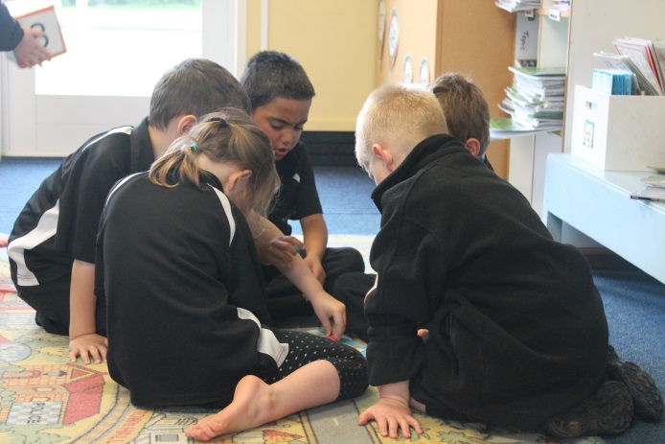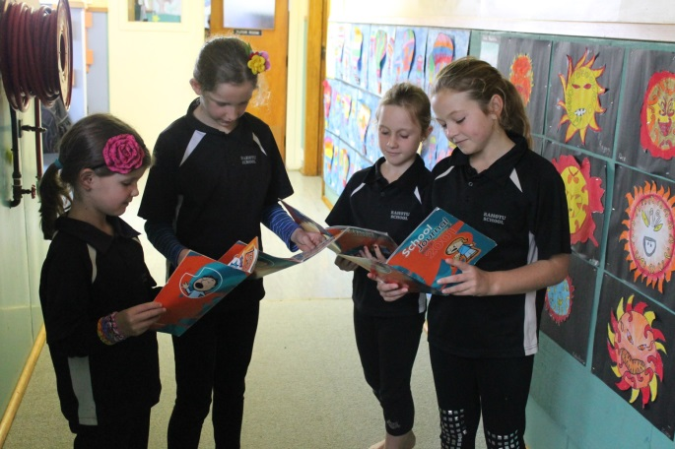

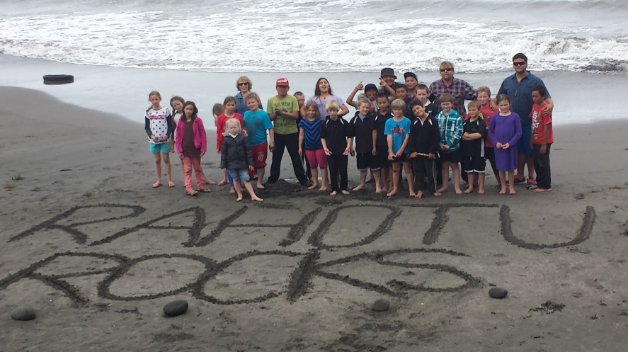

Flame – Rahotu School Respect Programme

Family / whanau / community

Learning

Aroha

Manaaki

Excellence

This programme teaches children values and their rights and responsibilities. It is the Positive Behaviour Management programme for our school and its structure has the expectation that all students, staff, parents and the Community are respectful to each other and we all work together to be good role models for the children.

The children have a focus –the current one being displayed throughout classrooms. All Flame focuses are based around Key Competencies and support our students to develop skills such as: Thinking, Managing self, Relating to others, participating and contributing, using language, symbols and texts. Children’s positive behaviour is rewarded throughout the term by afternoon sports days, movies, crafts, arts, as determined by our Hauora Leaders. Such activities include freeplay, movie afternoons, tabloids, craft sessions, dance, board games

|  |
| --- |
| Our Term Two FLAME Focus is:  Owning your own talk – think before you speak. |

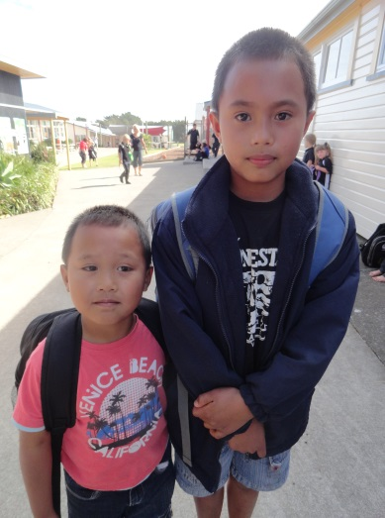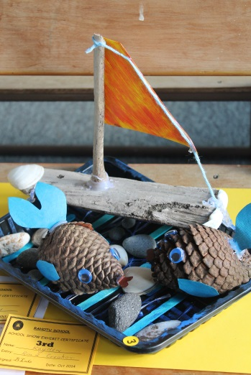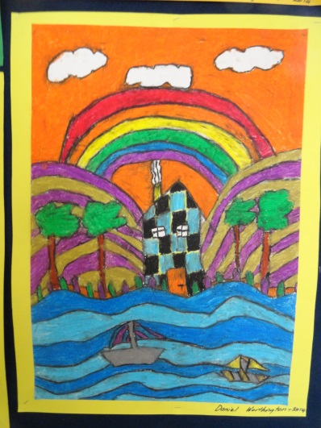

Transition to School **-** Transition to school operates in the New Entrant Room on the first **Thursday** of the month from 10-15 – 11.40 am. This involves all 4 year old children from the Play Centre and the Community.

Miss Lashford is the New Entrant teacher and she looks forward to getting to know your children.

Parents, your child is most welcome to attend half days 2 weeks before they turn 5. They can attend in the morning for a week and then a week in the afternoon. Parents can stay if they wish but if your child is settled you don’t need to. Children cannot go on the school bus until they are 5.

**Bus Code Of Conduct – February 2017** - This Code of Conduct is between student, their caregiver/whanau, Pickering Motors and Rahotu School. The caregiver and the student should ensure they have read and understood this document, which is to be adhered to for the safety of the Bus Driver and all students travelling on the school bus.

The behavioural expectations described below:

* When I am a seated passenger, I will remain in my seat for the whole journey.
* I will not eat and drink on the bus.
* If I am a standing passenger, I will stand quietly and not push or move around the bus.
* I will respect other students and their property at all times (this includes pushing, verbal or physical abuse, or any other behaviour that may distract the driver).
* I will use socially acceptable language when conversing with the driver and/or other students and I will speak quietly.
* I will respect the property of the Bus Operator at all times (eg: refraining from standing on seats or vandalising the vehicle in any way).
* I will not engage in any behaviour that could put the driver or other students at risk.
* I will observe the requirements and instructions of the Bus Driver and the Teacher/s responsible for bus duty.
* I understand that any damage I cause to the bus will result in my caregiver being billed for the cost of repairs.

The safety and comfort of everyone on the bus depends on a standard of behaviour and consideration for others that is expected in the classroom. We hope that caregivers will support the school in maintaining these standards of behaviour.

If this Code of Conduct is Broken:

* The student will be given first warning and it is recorded on bus warning sheet
* If the student continues to ignore the code of conduct, they will be given a 2nd warning – the caregiver will be advised
* If the student breaks the rules again, the caregiver is notified and they are excluded from travelling on the bus for a week
* If there is still no improvement, travel on a school bus will be withdrawn for the remainder of term, and the caregiver will be required to find alternative transport to ensure they are meeting their legal obligation to get their child to school..
* In extreme cases of misbehaviour the privilege of travelling on a school bus could be withdrawn immediately by the bus company in accordance with policy and procedures in the best interest and safety of all students

|  |
| --- |
| General Information |

1. **Absences -** Please contact the school before 8.45am if your child is going to be absent. There is now a designated phone to receive absentees 24/7. You just need to leave a message. We must account for all children, all the times. You are also able to txt your child’s absence to us on 027 9332308. Regular attendance at school is necessary to ensure learning occurs. You will be contacted if irregular attendance or lateness is affecting your child’s progress at school.A child must have a medical certificate if away three or more days.
2. **Accessories -** The school has a set of 30 black and white Canterbury jackets with the school logo. These are issued to children when participating in school activities at no charge.
3. **Assembly -** This takes place on Friday at 11.40 pm every second week and is organised by the Head students and Whanau Leaders. They are special occasions to celebrate individual and class achievements.

Whakatika kia Pai awards and Hot Shot awards are announced.

1. **Concerns -** If you do have a concern the first step is to deal with it in a courteous manner. And the most successful way is to sit down and discuss all aspects of the concern and help each other come to a solution which shows RESPECT to all.

An issue either with a Parent/Caregiver, a Staff Member or the Principal or the BOT must be dealt with in a professional and courteous manner that shows respect to all parties concerned.

**Procedures:**

In the first instance the person with an issue must phone to discuss issue and/or make an appointment to see the person concerned at a time that suits both parties.

Both parties must know the details of the issue **before** the meeting.

Both parties may have a support person if they so wish, at the meeting.

The meeting will be an open discussion that will endeavor to solve the issue.

-What are both parties understanding of the issue? What are the facts?

- Explain your point of view and explore the point of view of the other person

-Keep to the purpose of the conversation

-Consider each other’s feelings

-Avoid “Blame”. Value each other’s contribution

- What are the concerns of both parties ?

- How do you think this issue should be solved?

-Suggestions to remedy the issue.

The concern and discussion will be recorded and a copy will be given to the person with the concern- both parties will sign the minutes.

If an understanding cannot be reached the two parties will meet with the Principal. The BOT will be advised in writing if no amicable solution is found. A copy of the meeting notes will be attached to the letter.

If there is an issue that needs to be resolved the first port of call must be the school from the person/s concerned. It will not be acceptable to hear issues via the community or from students.

If the above procedures are not followed the BOT will be advised immediately and a meeting of all parties will be arranged.

Understandings from both parties

-We do not speak in front of other children when discussing matters of concern.

-We do not use inappropriate language (swearing or abusive words)

-We do not raise our voices- we speak in a respectful way

**Conclusion:**

All parties can expect to have issues openly discussed and solved with respect and care in a confidential manner.

1. **Bicycles -** Children must wear approved and safe, safety helmets, suitable clothing and covered shoes if they are biking to school. Children leave their bikes in the stand by the front gate. Every Wednesday is a wheels day. Children are permitted to bring scooters, and skateboards to school. Please remember they will need helmets.
2. **Bookclub -** Lucky, Arrow and Star Book Clubs.

Once a month lists are sent home. The order form is returned to school with the payment in a sealed envelope. Cheques must be made out to *Scholastic New Zealand*

1. **Buses -** Many of the pupils are transported by bus. There are two bus routes. Route No 1 North, Route No 2 South

There is a Code of Conduct form for children and parents of bus children to sign. Children who don’t usually travel on the bus but go to Technology at Opunake High School must sign the form as well.

If a child is misbehaving on the school bus the bus company will inform the Principal and parents will be informed. If the behaviour does not improve the child will not be able to travel on the bus for a week.

The Bus Company has the right to refuse a child a ride on the bus if the child’s behaviour is not acceptable. Last year in the interest and safety of all students we introduced GoPRO cameras to monitor behaviour. Visual information obtained from this camera will only be shown between the bus company, staff and parents of children concerned. Information will be deleted on a weekly basis.

|  |
| --- |
| School Bus – Code of Conduct   * Sit down and stay in your seat until the bus stops at your home/bus stop. * Be patient * Put your bag under the seat or on your lap or on the rack. * Speak quietly to each other   Be polite and listen to the drive |

1. **Cellphones -** If you require your child to bring a cell phone to school for after school use the child must hand it into the office on arrival at school and collect it after school.
2. **Cultural Activities -** Different cultural and Arts activities are promoted and children are given the opportunity to participate.Activities include Kids for Kids choir, Out of Hours Music and Art, WOMAD workshops, visiting artists, Taranaki Arts Festival etc.
3. **Dental Clinic -** This year the Mobile Dental Caravan will be based at Rahotu School throughout the year. Dates will be confirmed in our school newsletter. If you have any problems at any other times you should contact the Rangiatea Dental Clinic in Spotswood on 06 751 1332.
4. **Donations -** All families are asked to make a voluntary school donation during the school year. This is a voluntary fee contribution and any amount is willingly accepted. The purpose of the 2015 donation is to support our FLAME project whose main aim is to improve LEARNING at our school.

*1 child $30*

*2 children $50*

*3 or more children $65*

1. **First Aid/Medical** - Should a pupil suffer an accident at school they will be attended to and if felt that the doctor’s advice is necessary, then parents will be notified. Please advise the office if your child needs to take any form of medical prescription during the school day. Parents must fill in an Administration of Medication Request/Consent form before any medication is administered by school staff. Our School Secretary, Leanne Wiringi, is our designated First Aide, person. All staff have completed a refresher First Aide course in January 2016.
2. **Fitness, Physical Education and Sport -** These are a valued part of our school programme. We expect all children to participate and to wear the appropriate clothing. In summer, swimming is a compulsory part of the school curriculum, so it is expected that all children swim everyday.

* *A note or phone call is necessary if your child is to be excused from swimming or physical education.*Children are encouraged to participate in team activities extending to Saturday morning or at school programmes i.e. Netball, Cricket, Rugby, Indoor Basketball, Touch Rugby, League, Indoor bowls, Golf, Soccer. Parents are asked to support and encourage their children with coaching, managing teams and helping with transport etc. We thank you for your ongoing support.

1. **Food at school -** Each day the children have 2- 15minute snack breaks and a lunch time of 45 minutes. During snack breaks the children are encouraged to eat something to eat that they can peel or unwrap before leaving the classroom so all rubbish is in the bin and they can eat on the way to play. Items such as yoghurt and bags of chippies etc must be left until lunch so rubbish can be put in the bin when finished. The children sit all together outside Room 4/5 to eat at lunchtime.
2. **Hauora Leaders -** Our Leadership teams under one umbrella called **Hauora Leaders**. This team will consist of Head students, Whanau Leaders, Year 7 Hauora Helpers and Year 6 Hauora Helpers. Their role entails being responsible for everyone’s health- physical, emotional, spiritual, social- “Making Rahotu a Healthier Place”. In 2016 Mrs Lancaster supports students in achieving this goal.
3. **Health Promoting School -** Rahotu School has been a Health Promoting School for twelve years. Health Promoting Schools display in everything they say and do, support for and commitment to enhancing the emotional, social, physical and spiritual well-being of all members of their community. Health Promoting Schools acknowledges the influence of the wider community and gives the education and health sectors a common base from which to promote health.
4. **Health Nurse -** The Nurse, Stephanie Livingston, visits the school twice a term or on request. Appointments can be made through the office. There is a referral process if there are any complicated problems.

1. **Hearing and Vision Testing -** Usually the tester visits twice a year to test new 5 year olds, children who need a retest and Year 7 students. If your child does not pass you will receive a letter for a referral

1. **Homework -** We encourage all children to dohomework. Your child will be given their Homework on a Monday and they return it on Friday Morning. All children will have a reader/book to read or share with you. These can be changed each day. Home readers will either be at an independent reading level or their latest guided reader so children should be able to read them confidently-if children cannot read the book easily it will not be a pleasant experience and it can turn them off reading. If it is too hard read it to them, which is still beneficial. It is good practice that children read at home daily. Older children could be encouraged to read newspapers, magazines, journals along with their library books. The children will also be required to do a maths activity- basic facts learning will be compulsory until all are learnt, spelling- either learning list at their level or meaning of words, research and perhaps a poem or song to learn.

|  |
| --- |
| 1. **Interviews/reports -** Goal setting/ Meet and greet interviews will take place at the beginning of the year. Although school will be open individual interviews will replace the normal class programme. This is a great opportunity to spend 15 minutes chatting about your child to your child’s teacher.   Written Reports will be sent out in Term two and again in Term four |

1. **Kapahaka -** This is usually on a Friday morning once a week, from Terms two and three.
2. **Leaving School Grounds -** Children should **not** leave the school grounds during school hours without staff permission. It is imperative if you remove your child from school earlier that you make direct contact with the school office not just the classroom teacher.
3. **Library -** We have an excellent, up to date library collection and we encourage children to borrow books for recreational reading. The library is automated and senior children are encouraged to be librarians. Please encourage your children to read.Children have an opportunity to change books everyday. The library is open at playtimes and lunch times for reading and changing books every day except Wednesday. Class visits to the library will be at least once a week to learn and practice information skills. If your child has an overdue book they receive a slip from the Librarian and they are expected to return it promptly. There is a charge for lost or damaged library books –this account will be sent in the mail. All children are allowed to borrow 3 books at a time.

*This year our library is open to our community members during the hours of*

*10.30 – 12.30pm Mon, Tues, Thurs and Friday – all welcome.*

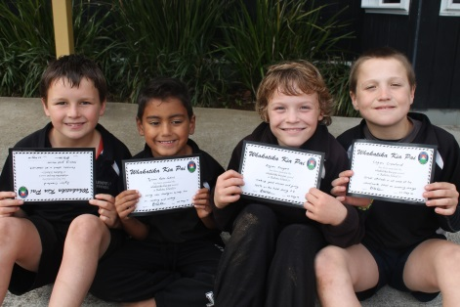

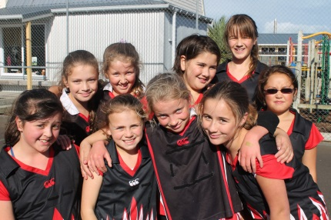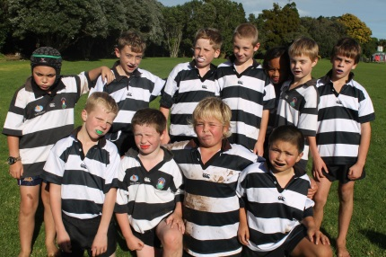

1. **Life Education Trust -** The mobile classroom visits the school each year as part of our Health programme. Over a three year cycle the children cover all aspects of the programme.
2. **Lost Property -** Please mark all clothing clearly. Lost property is put in a white plastic container in the corridor between Rooms 2/3. Regularly lost property is placed out on the Room 2 deck for children to claim. Any unclaimed property is left for you to claim over the weekend. Any unclaimed items at the end of each term will be disposed of or given to a suitable cause.
3. **Lunches –** School lunches can be order from the school on a Thursday morning before 9am. Correct change is required and the amount needs to be placed in a sealed envelope with student’s name, room number and order on the front of the envelope.
4. **Milk in Schools -** Fonterra provides milk for all students from Year 1-8 , weekly. There are milk monitors that deliver the milk to classrooms at 10.15 Monday to Thursday and stack the fridge with the boxes of milk. The students have learnt how to fold their carton when finished and they are put in the small blue recycle bin.

1. **Newsletter -** A dated Newsletter is sent out regularly - on a Thursday. If your oldest child is away on a Thursday the newsletter will be given to the younger child. If they are the only child at school the teacher will write their name on the outside and your child will be given the newsletter when they return to school. If you are not receiving your newsletter each week please let us know immediately. Please supply the office with your email address if you require the newsletter to be emailed as well. If you would like a notice in the newsletter please email it to the school by Wednesday 1pm at the latest.
2. **Parental Involvement -** There are many ways in which you, as a parent can help in our school. We welcome assistance in any of the following areas:

**Options:** Parent Help, Library assistance, Processing/Strengthening books, Reading tutoring,

Sports programmes/Coaching, painting, Grounds – working bees, Swimming/lifeguards, transport, making resources.

We will ask for help via our school newsletter.

1. **Picking children up from school -** If you pick your child up from school please park on the school side of the road or come into school and see your child across the road. If your child is not going on the bus please let the office know. A message on a sticky will be put on the bus list so the bus controller knows exactly who should be on the bus.
2. **Playcentre -** The Rahotu Play Centre is situated in the ex classroom nearest the main road – entrance via Memorial Gates or the side gate. For further information contact the President: Kat Greaney. Sessions are on a Tuesday and Thursday morning- 9.30-12.30.
3. **Property – Broken Windows/equipment -** If any school property is intentionally damaged or broken, the pupils will be required to pay for its replacement. This will include pupils acting in a thoughtless manner.
4. **Reading Recovery -** This year Lynne Mackay will take two children on the programme at a time. Children are selected on this programme after their 6 year survey has been completed-usually between the ages of 6-6.5. Parents will be informed if their child has been selected for the programme. Each of children has a half hour reading/writing lesson per day. It is a requirement if your child is on the programme they must attend regularly and the extra home work is completed each night. Your child will have an extra reading folder with their Reading Recovery Homework.
5. **Recycling -** The students are trained to recycle and the school takes part in the “Paper for trees” project sponsored by Shell Todd Oil Services. The senior students empty the recycling green boxes in to the blue bins each day. The number of blue bins we put out for collection each week earns the school trees- One plant for each blue bin sent. The school grounds are benefitting by the plants donated to the school. Thank you Shell Todd.
6. **Resource Teacher of Learning and Behaviour -** Tasha Kruger is our RTLB who is based at Coastal Taranaki School. Any parent who is concerned with their child’s behaviour or learning please contact the Principal for assistance.
7. **Resource Teacher of Literacy -** Our RTLit is Tina Johnson at Ramanui School in Hawera. Referrals can be made twice a year. The RTLit monitors the progress of a small group of children in her focus schools. For the first half of the year Tina is supporting children across years 5 and 6.
8. **Resource Teacher of Maori –** Our RT of Maori is Maora Koopu who is based at Ramanui School.
9. **Sun smart- Rahotu is a Sun Smart School -** Children need to wear clothing that protects them from the sun e.g. shoulders and backs covered. Sunscreen is available in each classroom. It is compulsory for all students to wear a Rahotu School hat when outside in Term 1 and 4. No hat = you have to sit in the shade. Children can purchase a hat for $12.00. Hats stay at school each day and they are washed at the end of each term. There are two sun shades over the court yard and a verandah over the deck outside Room1 and 2 to protect the children from the sun. There is also a sun shade over the large sandpit. A solid sunshade is also over the concrete outside the main block.

*A fig tree was presented to the school by the Cancer Society*

*which is growing between the Adventure Playground and the Main Block.*

*One day it will be large enough to be a shade tree in this area.*

1. **Sports Teams -** Sports uniforms are available for miniball, basketball, netball and rugby. There is also a set of 30 Canterbury Jackets for school outings. Whenever a uniform is used the number is recorded by the student’s names. The school jackets are collected after each outing, children are not to take them home. Parents and pupils are responsible for this gear while they are borrowing them. Please note: If any item is lost or damage parents will be asked to replace the item.
2. **School photographs -** Each year the school engages the services of a photographer for class and individual photographs. This will take place at the start of Term four.
3. **Smoking -** Rahotu School is a Totally Smoke free school. The school prohibits the use of tobacco products in any form in any of the school buildings, facilities and grounds at all times, by any person associated with the school and any visitors using the school grounds.
4. **Stationary -** Children get their stationery list for the following year with their end of year school report. At the beginning of the year pupils can buy their stationery through the school office. Stationery is also available throughout the year. Your child will receive a stationery slip with the item required and the amount. The school stocks stationery requirements at very reasonable prices and does not make a profit.
5. **Swimming Pool -** The pool is in operation from the beginning of the year through to mid April (Weather permitting). When our swimming programme is in action we expect children to swim everyday. Appropriate swimwear for swimming instruction is required**.** One piece swimsuits are desirable, no string bikinis, below the knee shorts are unacceptable and no big T shirts. Fitting T shirts and rash shirts are acceptable.
6. **Technology -** Year 7 and 8 pupils go to the Technology Centre at Opunake High School once a fortnight on a Friday for instruction. Year 7/8 will all go on the same day. The children leave Rahotu School at 8.50 am and return at 2.30 pm. As hours have extended from previous years it is imperative that students arrive at school on time and ready for the bus. Children are transported by bus. Parents are required to pay Tech fees of $50.00 each year. Rahotu School pays the total amount to OHS and the parents pay Rahotu School. This payment is to cover the cost of materials your child uses.
7. **Uniform** - From the beginning of 2011 the Rahotu School Uniform was compulsory. The uniform consists of a black and white polo shirt and sweatshirt and hat which are ordered through the school. An alternative black and white school jacket is also available but not compulsory. Any queries contact Belinda Allan on 06 7638842 Thank you to Karams of Opunake who supply the uniforms. Orders are taken at various times during the year- these are advertised in the school newsletter. Students must wear black on the bottom-skirts, shorts, track pants, tights, and longs. Parents purchase these items. Students can wear any shoes. A neutral coloured thermal can be worn under the polo shirt. (No stripes) The school hat is also part of the uniform in Term 1 and 4.
8. **Uniform/Jewellery -** The only Jewellery girls can wear is stud earrings and a watch. Boys can wear a watch only. If your child has a necklace/taonga of special significance you wish them to wear all the time at school please write a letter requesting dispensation. We do not accept responsibility if your child is injured if their necklace gets caught in play equipment or gets broken during play etc.
9. **Whanau Teams -** We group our school vertically in Whanau Teams. Each of the four Whanau Teams are each given a name of a native tree which are located in the school grounds- Puriri (Green), Totara (Red), Kauri ( Blue) and Rimu (Yellow). Whanau Leaders are elected every six months. The senior students in each Whanau Team are responsible for duties around the school every 4th week. The teachers allotted to each Whanau Team will ensure duties are carried out and will have a meeting with their team the week before they are on duty.
10. **Water -** It is essential children have water during the day. Each child is distributed with a named drink bottle which is washed in the dish washer weekly. There is a water filter outside the staffroom for children to fill their drink bottles up.